ISYS3004 Web Fundamentals Portfolio – Final Documentation
Eugenie Wiratan 22260637
Assessment 1 Web Fundamentals Portfolio

1. Introduction
This portfolio project documents my development across multiple checkpoints, progressing from basic semantic HTML to a fully interactive website incorporating CSS, JavaScript, and API integration.
The goal of this project was not only to build a functional website, but to demonstrate understanding of web development principles including structure, design, interactivity, and data integration.

2. Reflection
At the beginning of this project, my understanding of web development was mainly focused on how a website looks rather than how it is structured and functions behind the scenes. Through the checkpoints, I developed a clearer understanding of how HTML, CSS, and JavaScript work together as a system.
In Checkpoint 1.1, I learned the importance of semantic HTML. Initially, I considered using <div> elements for everything, but I realised that using structured elements such as <header>, <nav>, <main>, and <section> improves both readability and accessibility. This also helped resolve validation issues and made my code more organised.
In Checkpoint 1.2, I developed my understanding of CSS. At first, I struggled with linking external stylesheets and structuring my styling. Over time, I learned to apply styles systematically, starting with global styles and then refining layout and components. I also implemented responsive design using media queries, which allowed my website to adapt to different screen sizes. Additionally, I refined my visual direction by shifting to a monochromatic design that better reflects my personal style.
In Checkpoint 1.3, I was introduced to JavaScript interactivity. I implemented a dark mode toggle and a project details expansion feature. Through this process, I gained a clearer understanding of DOM manipulation, event handling, and how JavaScript interacts with HTML and CSS. Implementing localStorage helped improve user experience by preserving user preferences across sessions.
In Checkpoint 1.4, I learned how to integrate external data using APIs. Initially, I found it challenging to understand how data is fetched and displayed. By breaking the process into steps, I developed a better understanding of asynchronous programming using async and await. I also implemented error handling and loading states to improve reliability and user experience.
Overall, this project shows my progression from simply building static pages to creating a more dynamic and interactive web application. I am now more confident in structuring code, debugging issues, and making design decisions that align with both functionality and user experience.

3. Features Implemented
The final portfolio includes the following features:
- Semantic HTML structure using <header>, <nav>, <main>, <section>, and <footer>
- External CSS styling with a consistent monochromatic design
- Responsive layout using media queries
- Dark mode toggle using JavaScript and localStorage
- Interactive project details toggle using DOM manipulation
- GitHub API integration to display repository data
- Quote generator using external API
- Error handling and loading states for API requests

4. AI Usage
AI tools were used throughout the development process to support understanding, debugging, and refinement of the portfolio.
In the early stages, AI was used to clarify the use of semantic HTML and proper page structure. This helped ensure that the website followed best practices rather than relying on generic layout elements.
During CSS development, AI assisted in identifying issues such as incorrect file paths and provided guidance on structuring styles effectively. It also supported the implementation of responsive design and encouraged adjustments to better reflect my personal design style.
For JavaScript, AI was used to support the implementation of interactivity features such as the dark mode toggle and project detail expansion. It helped clarify concepts such as event handling, DOM manipulation, and the separation of concerns between HTML, CSS, and JavaScript.
In the final stage, AI played a key role in debugging API integration. I encountered issues with unreliable APIs and incorrect data handling. AI guidance helped implement error handling, loading states, and improved filtering of GitHub repository data to ensure only relevant content was displayed.
All AI-generated suggestions were reviewed and adapted. The final implementation reflects my own understanding, with changes made to ensure correctness, usability, and alignment with assignment requirements.

5. Before and After Improvements

Figure 1 – Dark Mode Toggle
Before:
- Static light interface
- No user customisation
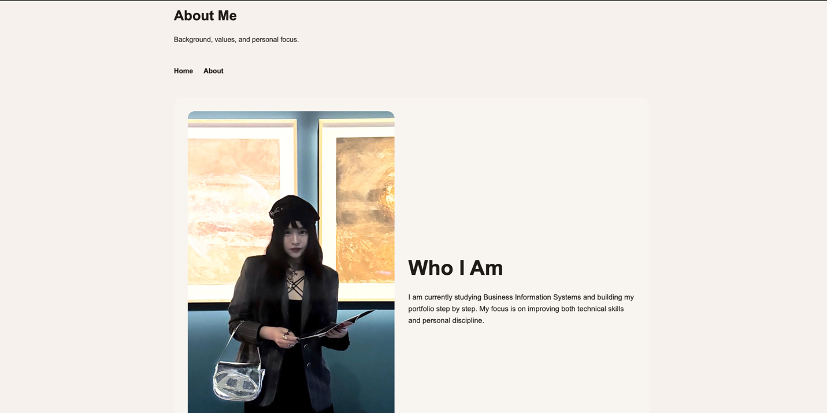
After:
- Dark mode toggle implemented
- Theme preference saved using localStorage
- Improved user experience and visual flexibility
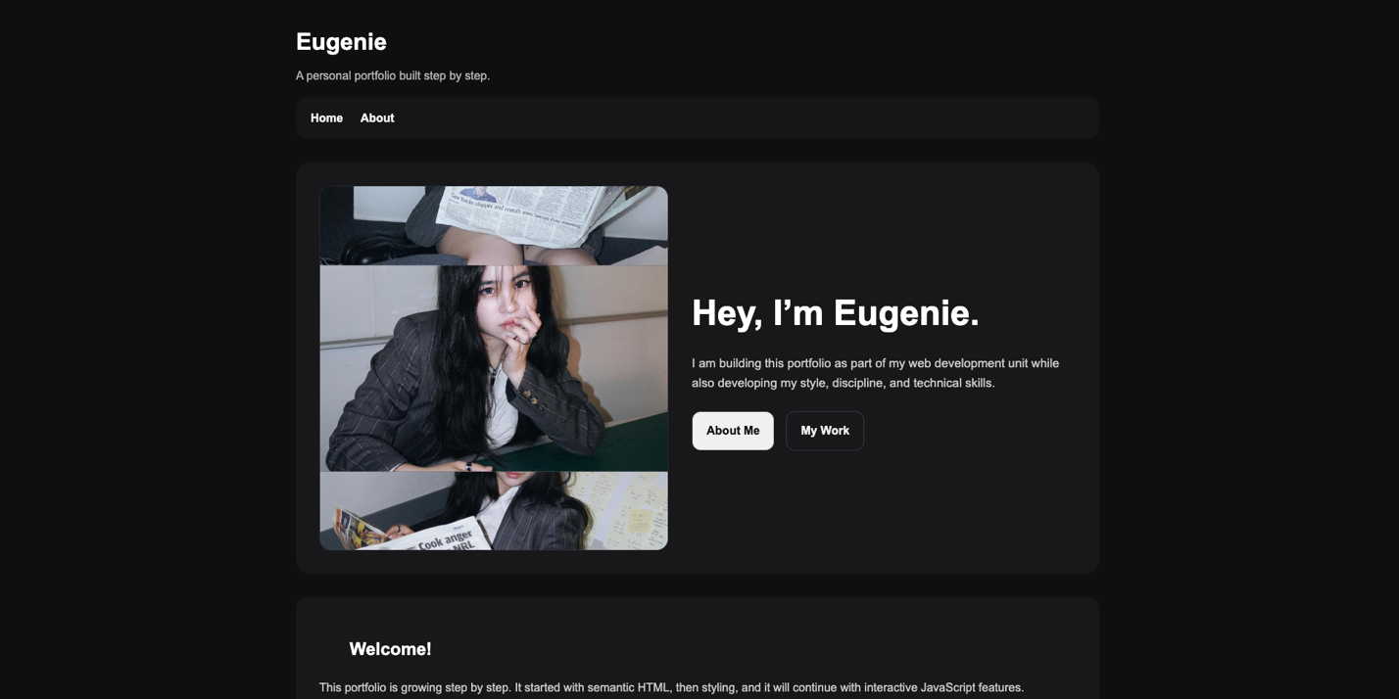
Explanation: This feature demonstrates JavaScript event handling and DOM manipulation. It also improves usability by allowing users to control their viewing experience.

Figure 2 – Quote Generator (Error → Fixed)
Before:
- Quote generator failed to load data
- Displayed error message
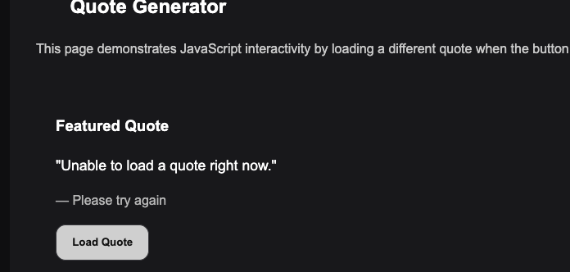
After:
- Integrated working API
- Displays dynamic quotes with authors
- Improved reliability and functionality
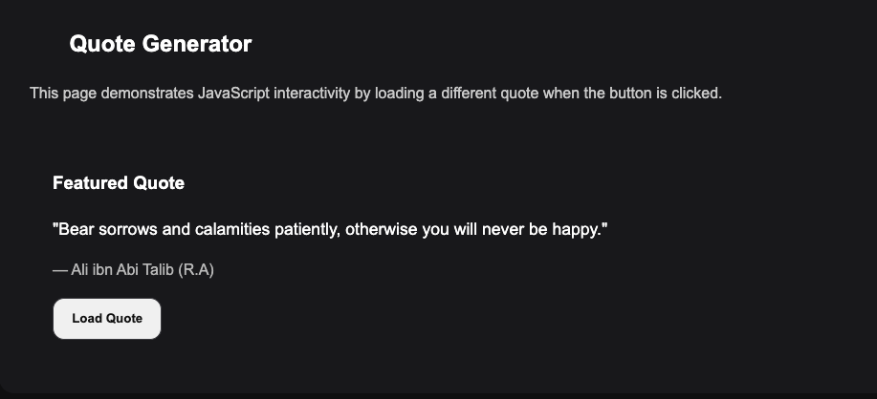

Explanation: This demonstrates debugging, API integration, and error handling using try/catch. It also shows understanding of asynchronous data fetching.

Figure 3 – GitHub Repository Selection
Before:
- Displayed multiple unrelated repositories
- Reduced clarity of portfolio purpose
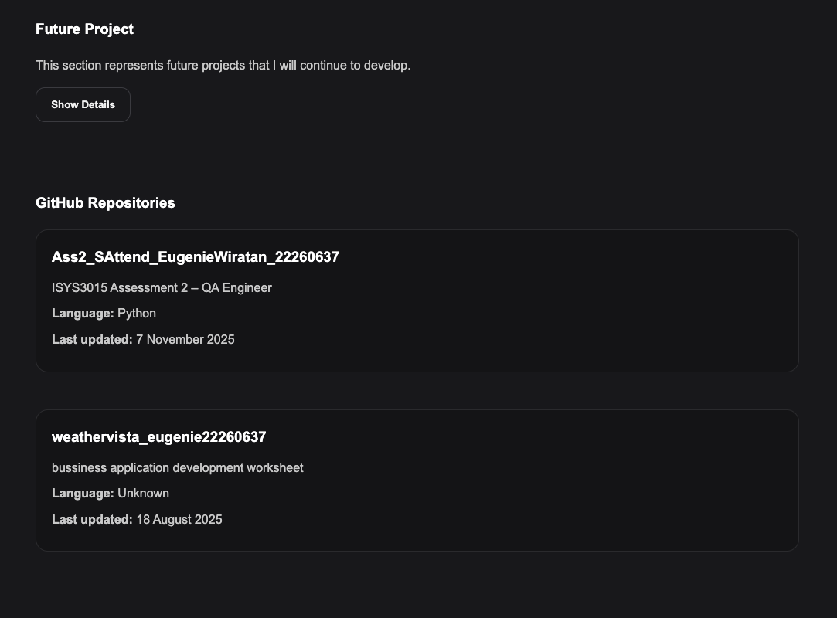
After:
- Filtered to display only the portfolio repository
- Improved relevance and presentation
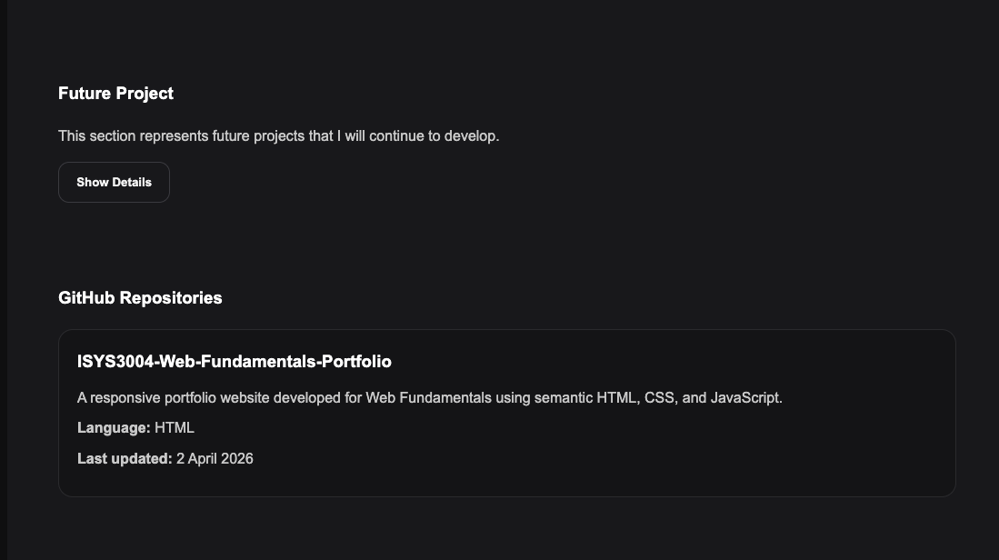

Explanation: This demonstrates data filtering and intentional design decisions when working with API responses.

6. Accessibility and Performance
Accessibility was considered through the use of semantic HTML elements, descriptive alt text for images, and structured navigation. Interactive elements such as buttons include appropriate attributes such as aria-expanded to improve usability.
Performance was improved by using efficient JavaScript practices, including limiting unnecessary DOM updates and implementing loading states for API calls. The website is deployed using Netlify, ensuring fast and reliable access.

7. Conclusion
This project represents my transition from basic web page creation to building a more complete and interactive web application. I developed a stronger understanding of how structure, design, and behaviour work together, and gained confidence in debugging and improving my work.
The final portfolio not only meets the assignment requirements but also reflects my personal style and growth as a developer.

Github Link:
Netlify Link:

